Chess Variants
v0002
Games played on a standard chessboard and using standard pieces
Variants listed alphabetically

Atomic Chess

Background: Unknown inventor
Rules:
* Normal rules apply, but there is no check or checkmate
* When a piece is captured, an explosion occurs on the capture square. The explosion removes:
- the capturing piece
- the captured piece
- all pieces, except pawns, on surrounding orthogonal squares (ie. a king's move away)
* A player wins by removing the opponents' king (by direct capture or explosion)
* Moves which cause a player's own king to explode are not allowed

Avalanche Chess

Background: Invented by Ralph Betza
Rules:
* After making a move, the turn player must advance one of the opponents' pawns exactly one square forward. A moved pawn in this phase of the turn cannot capture a piece (or a pawn).
* If the opponent has no pawns, or none can be moved, this part of the turn is skipped
* A pawn is promoted to a piece of the owners' choice, regardless of which player advanced the pawn to the promotion square
* A king in check must escape on the first move of a turn
* A move into check is not allowed even if moving an opponents' pawn on the second half of the move would have removed the check
* If a player is obliged to advance an opponents' pawn so as to put his own king in check, or an opponents' pawn moved in the second half of a players' turn is promoted to give check, the player loses even if they delivered checkmated on the first part of their turn

Coin Chess

Background: Unknown inventor
Rules:
* Normal rules apply except for the introduction of a coin (or counter)
* Black starts by placing the coin on any unoccupied square. Play then continues with players alternating turns as in normal chess.
* On their turn, a player makes any legal move but may not move onto the square where the coin has been placed. The player may move over (but not onto), the coin square.
* The player ends their turn by leaving the coin where it stands or moving the coin to a different unoccupied square.
* The coin can never be placed on an occupied square, and therefore cannot be used to protect a piece from capture
* A player wins by checkmating the opponent. Note that the coin can be used to remove escape squares from the king.

Extinction Chess

Background: Invented by R. Wayne Schmittberger
Rules:
* Normal rules apply
* There is no check (you may capture the king)
* A player wins by capturing all of the opponents' pieces of one type (eg. both knights)

King of the Hill Chess

Background: Unknown inventor
Rules:
* Normal rules apply
* A player also wins by making a legal move with their king to one of the centre squares (d4, d5, e5, e5). The move must be legal, so the king cannot move into check.

Knight Relay Chess

Background: Invented by Mannis Charosh. Also known as N-Relay Chess.
Rules:
* Knights have relay powers. Any piece defended by a friendly knight gains the power of the knight move, except for the king which is unaffected. For example, from the starting array, the White e-pawn can move to (or capture on) c3, d4, f4 or g3 in addition to the standard options of e3 and e4.
* Pawns and pieces may be relayed forwards or backwards, but pawns may not be relayed to the first or eighth rank
* Any pawn relayed to its' initial rank regains the option to make a double-step move
* There is no en passant capture
* Knights are immune from capture, cannot capture enemy pieces and cannot give check
* Pawns may promote to a knight and promoted knights also have relay powers, are immune from capture and cannot capture enemy pieces

Jump Chess

Background: Invented by Alain Dekker
Rules:
* Normal rules apply
* Pawns, knights and the king move as in standard chess
* Bishop, rooks and the queen have an additional option of jumping from one side to the other side of any piece (or pawn). The jumped piece can belong to either player. Start and end squares must be immediately adjacent to the jumped piece, so will be exactly two squares apart.
* For example, from the starting array, the White queen may move to b3, d3 or f3
* A jump can be used to capture an enemy piece or to give check (or deliver checkmate)

Loop Chess

Background: Unknown inventor. Also known as Crayhouse, Drop Chess. Two-player variant similar to BugHouse (or Exchange Chess).
Rules:
* Two full sets and one board are required. Place the extra set in a pool alongside the board.
* Normal rules apply
* Captured pieces change colour. Place the captured piece in the pool and take the same piece, but with opposite colour, and place it in front of the capturing player as a reserve.
* Instead of making a move with a piece on the board, a player can drop a piece from their reserve onto an empty square on the board (as in Shogi). There are no restrictions on the number of pawns in a file, or the square colour for a bishop.
* Dropped pieces, including pawns, may give check, deliver checkmate or block check
* Pawns may not be dropped onto the 1st or 8th ranks
* Pawns dropped onto to its initial rank have the option to make a double-step move
* Pawns promote as normal. If a promoted pawn is subsequently captured, the captured piece reverts to a pawn. Some mechanism to identify promoted pawns, such as a checker underneath the piece, is required to identify promoted pawns.
* Dropped rooks cannot be used to castle

Losing Chess

Background: Unknown inventor. Also known as Loser's Chess, Suicide Chess, Antichess, Giveaway Chess.
Rules:
* Captures are mandatory but a player is free to choose between alternatives
* There is no check (the king is captured like an ordinary piece)
* A pawn can promote to a king
* A player wins by losing all their pieces, or if they do not have a legal move

Monster Chess

Background: Unknown inventor. Also known as Super King Chess.
Rules:
* Variant starting position. Black starts as normal. White starts with a king and four pawns (c to f) only. See figure.
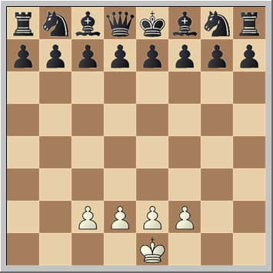

* White makes two moves on their turn. Black makes a single move on their turn.
* White may promote a pawn, but Black may not promote. Any Black pawn reaching the promotion square remains a pawn and will not be able to move again. Some versions state that Black is allowed to promote, but the version described here is to be preferred.
* There is no check and a player wins by capturing their opponents' king

Progressive Chess

Background: Unknown inventor. There are two main variants called Italian and Scotch Progressive Chess (the differences are discussed in the rules).
Rules:
* White starts with one move; Black then makes two consecutive moves, either with the same piece or with different pieces; White follows with three consecutive moves, and so on with the number of moves increasing by one each turn. White always plays an odd number of moves and Black always plays an even number of moves.
* A player in check must escape check on the first move of their turn otherwise they are checkmated
* Giving check:
- Scotch Chess: A player's turn ends immediately if they give check, regardless of the number of moves made
- Italian Chess: Check may only be given on the last move of a full series. Giving check before the final move of a series is illegal. If the only way to escape a check is to give check on the first move of a series, the game is lost by the player in check.
- Scotch Chess is simpler and is to be preferred. The variant being used will be specified.
* Players may not expose their king to check at any stage on their turn
* If at any stage before the end of their turn, a player has no legal move, but is not in check, the game is drawn
* An en passant capture must be made on the first move of a series, the captured pawn having made a two-step move (and no other move) at any stage during the previous turn

Racing Kings

Background: Invented by Veron R. Parton
Rules:
* Variant starting position with no pawns (see figure)
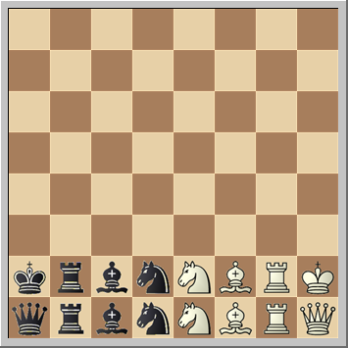

* Captures are allowed, but a player may not give check to the opponents' king
* A king is not allowed to move to a square which is attacked by an opponent's piece
* A player wins by moving his king to the last row
* If White moves their king to the last row first, Black draws if they are able to move their king to the last row on the next move. If Black moves their king to the last row first, the game is won by Black.

Three Check Chess

Background: Unknown inventor
Rules:
* Normal rules apply but a player also wins by giving check three times
* Separate counters may be used to keep track of the number of checks given

